DAY -3

Minikube version

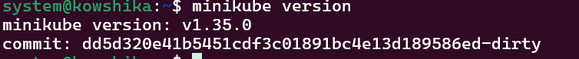

Minikube start

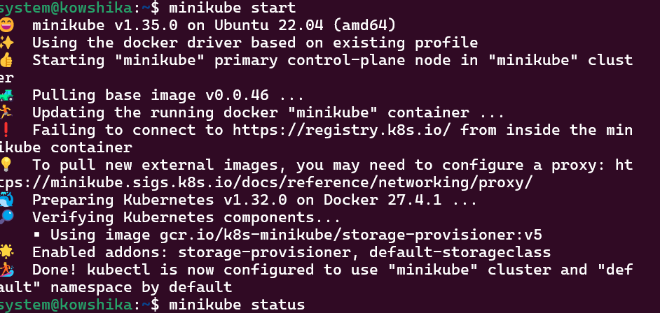

Minikube status

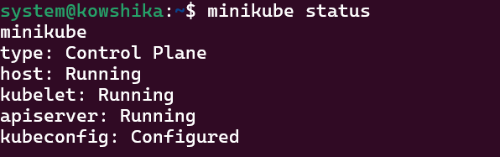

Sudo nano nginx-deployment.yml

kubectl apply -f nginx-deployment.yml

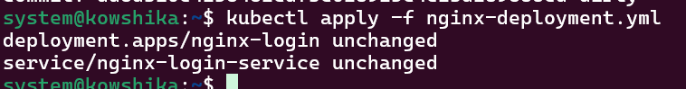

kubectl get deployments

kubectl get pods

kubectl get services

minikube ip

http://<MINIKUBE_IP>:30008

output:

